**Project 1**

Fiona Liu (A16880107) and Yanhao Ji (A16633225)

Course: Design of Everyday Things (DSGN 1)

Studio Section: Wednesdays, 9:00AM PST

For this project, we centered our focus on a single automobile feature: the automatic transmission gear stick. After comparing, we decided that the traditional gear stick of the Audi Q5 was a good design, whereas the modern take in the Honda Odyssey constituted a bad design. Key distinctions between good designs and bad designs can be characterized by their discoverability and understanding, which tests how easily users can figure out the product as well as how well the product can be put to use. In the case of a gear stick, this is particularly crucial, as the smooth operation of a motor vehicle has major safety implications. The specific parameters that we based our analysis upon can be found in the textbook, including affordances, signifiers, mappings, feedback, mental models, gulfs of execution and evaluation, etc., and will be discussed further in detail in our project.

**Good Design: Audi Q5 Gear Stick**

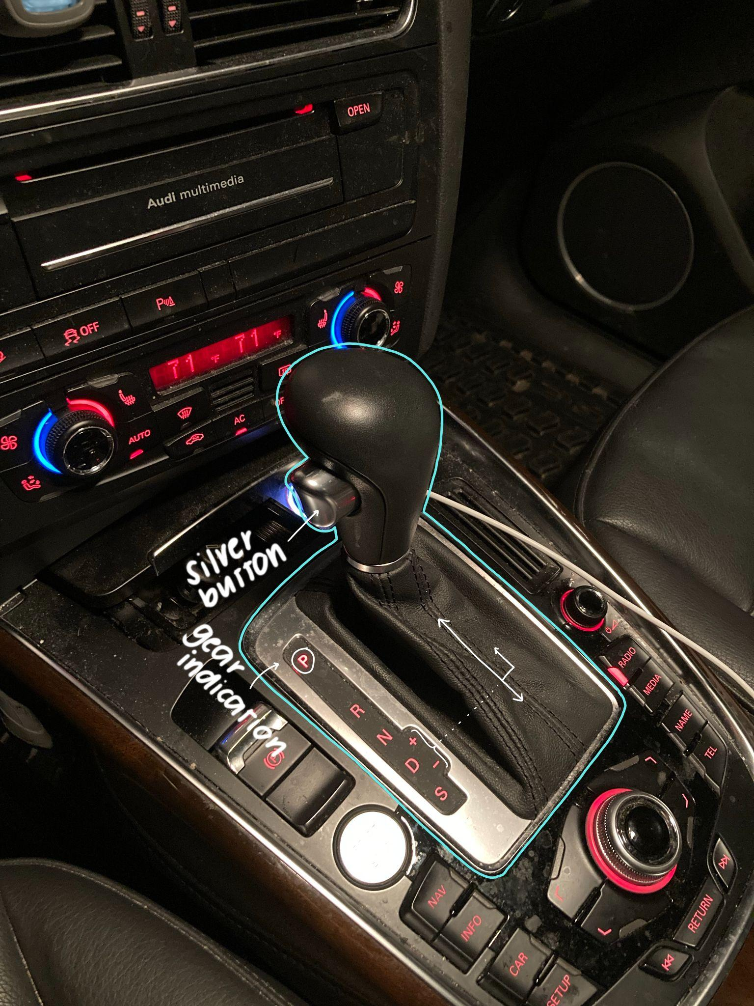

Figure 1: The gear stick in the 2011 Audi Q5

In an automatic transmission car, the driver is not responsible for manually shifting gears, but rather relies on the pre-established settings. The gear stick is responsible for shifting between these settings, and is outlined in blue in Figure 1.

This lever-based style of gear stick is relatively common, and simply requires the driver to pull the lever to the desired gear while simultaneously holding down the button.

1. **Affordances**: Affordances are defined in the textbook as the “possibilities in the world for how an agent (a person, animal, or machine) can interact with something,” and form a relationship by that action (Norman 18).
   1. The lever can **afford** to be gripped, and by that, also can **afford** to be pushed or pulled.
   2. The silver button can **afford** to be pushed, and because it only operates when the lever is pushed/pulled AND the button is pushed and held, it also **affords** a safer experience, as it ensures that there is resistance so you won’t accidentally nudge the stick and shift gears.
2. **Signifiers**: Signifiers, by textbook definition, are perceivable signals that indicate where action is possible. (*Perceivable affordances can also function as signifiers, but may be misleading)
   1. The curvature of the lever could be considered as **signifying** that it can be gripped in the palm of the hand, as the human hand can only cup comfortably in one direction.
   2. The protrusion, difference in color, and small indentation of the silver button all contribute to **signifying** that the button can be afforded to be pushed.
   3. The letters beside the lever are **signifiers** that indicate which gear will be shifted depending on the position the driver moves the lever.



Figure 2: An animation showing how the lever work

1. **Feedback**:Feedback communicates the result of an action and lets the user know if the attempt was successful or not.
   1. When the lever is pulled, it clicks; this click is **feedback** for the user to know that they are in the desired position.
   2. Additionally, after the lever is in position, the letter of the position will light up, which also gives the user **feedback**. In Figure 1, the letter P is lit up because the car is in the park gear.
   3. One can also argue that lack of feedback is feedback - if the driver isn’t holding the button down but is pushing/pulling the lever, the lever will stay put; this lack of movement and obstinacy is a form of **feedback** that tells the user that the attempt was unsuccessful.
2. **Mapping**: The mapping of something is the relationship of position and layout between the elements of the objects.
   1. The gear shift is in a center position that aligns to the hand when sitting down with the arm on the arm rest; this **mapping** is comfortable to reach in the intended position that was designed.
   2. The elevation of the stick is also successful **mapping**, as it does not result in the accidental pressing of any other buttons.
   3. The order in which the letters appear is also mindful **mapping**; the park is far above the other gears, meaning there won’t be any confusion that could potentially cause the car to move forward or in reverse by accident.
      1. To the side of the letters, there is also a small extension of + and -, which allows users to shift to a manual mode where they can upshift and downshift gears to their discretion. The lever follows this pattern of movement; in order to be in that setting, the user has to move the lever right in the aligned area, and then up or down. The **mapping** of the letters mimics the permissible functions of the gear sticks.
3. **Mental Models**: **Mental models** will vary by designers and users; the designer’s mental model may have one intention, but how the user mentally figures out the design based on visible operating parts and their implications may result in something else. This combined relationship would be defined as the **system image**. The lever design of this gear shift provides a sense of fluidity when changing between gears, as opposed to the separateness of buttons (discussed in next design), which could likely be part of the designer’s reasoning. The design gives little room for error, as there is only one correct way to shift the car in a certain gear based on the given signifiers (push and hold the button, and push/pull the lever), meaning the designer’s mental model and the user’s mental model must be similar, making this a successful design. Additionally, because this design is so consistent with other models of cars, users who have prior experience with gear shifts like this one will have a very clear **mental model** of how to operate it.
4. **Gulf of Execution and Evaluation**: The **gulf of execution** asks the question of how something operates by using **affordances** and **signifiers**, while the **gulf of evaluation** tries to figure out what happened and if it worked by using **feedback**. Because the curvatures, colors, protrusions, etc. of the signifiers make the affordances so clear, the gear stick bridges the gulf of execution extremely well, and the user can easily discover the correct way to operate the gear stick. Additionally, aside from the actual movement of the car as a result of the gear shift, the feedback of the lit letters bridges the gulf of execution successfully by letting the user know that their attempt was successful.

**Bad Design: Honda Odyssey Gear Stick**

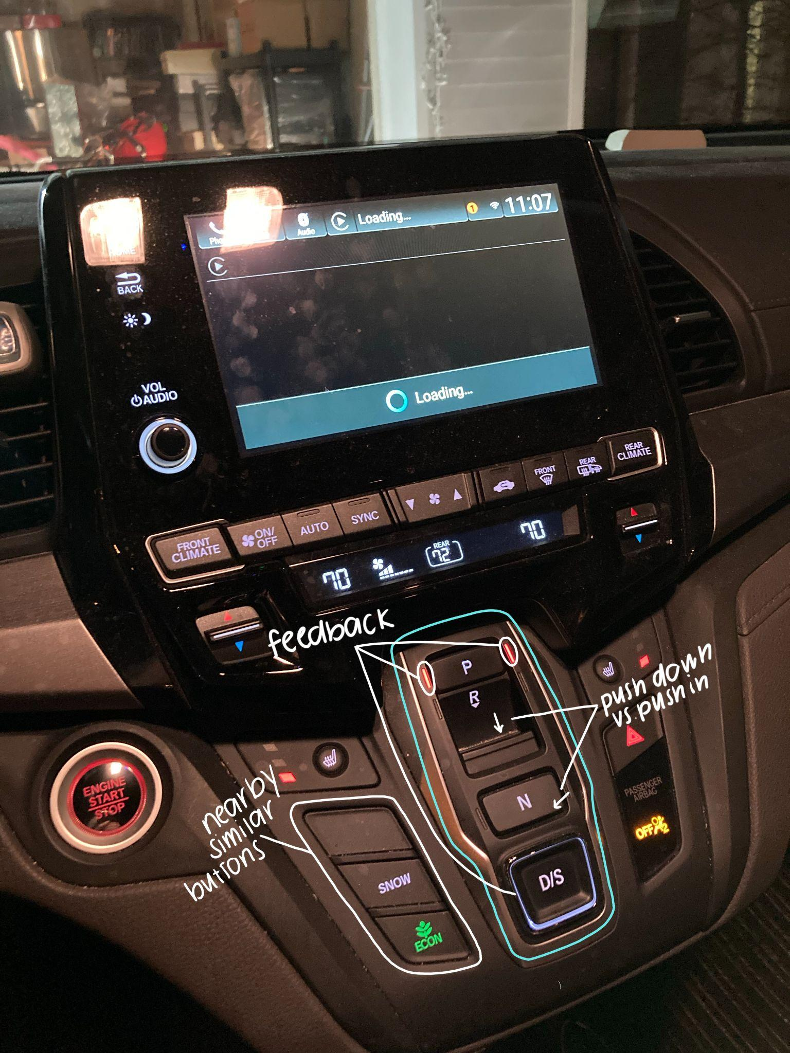

Figure 3: The gear stick in the Honda Odyssey

The Honda Odyssey takes a more unconventional approach to the gear stick, using buttons instead of a lever. Ironically, this more modern take poses more problems than it does solutions.

1. **Affordance:** 
   1. Buttons and divots on the middle of the control panel can **afford** to be pushed, and gaps surrounding the buttons let users know of this **affordance**, as there is a depression that the button can go into. The arrangement for **affordance** is poordue to many different buttons all crowded in the same place; the gear shift buttons can be **afforded** to be pushed, but so can all of the other buttons. Users can easily push the wrong buttons when they are driving and can not look at the control panel.



Figure 4: An animation showing how the buttons work

1. **Signifer:** 
   1. Divots in the control panel are obvious which can **signify** users where to push for using the gear stick buttons, and the letters work as **signifiers** to indicate users the location of the gear stick. The location of the gear stick **signifier** is in the middle of other buttons, which is quite misleading when users are driving and do not have enough time to check if they push the correct button.
   2. Another misleading button would be the R button. The large gap changes the orientation at which the button is pushed (down instead of in), but it’s visibly inconsistent with the other buttons, which could lead to a confusion when looking at the **signifier**.
2. **Feedback:** 
   1. There is no aural **feedback** when users use the gear stick, which can cause confusion for users when they are in a situation where they can only depend on auditory feedback, like in situations of colorblindness.
   2. For the D/S button, it will light up with a green ring once users push the button, which is a visual **feedback**; however, its inconsistency with the other feedback of two red lines (like in P in Figure 3) causes it to be confusing.
   3. An **feedback** problem encountered by experience was that the buttons are quite deep and can’t be quickly pressed, so the user could think he/she/they pressed the button deep enough, but didn’t, yet also have no idea because there isn’t any feedback.
3. **Mapping:**
   1. The **mapping** of this gear stick design is horrible, as it is amongst other buttons for radio, temperature, etc., and can be easily confused, posing a safety hazard. When drivers drive this vehicle on the road, they need to focus on the road and focus less on the control panel inside the car. The poor **mapping** system that squeezes all the buttons together will easily cause drivers to push the wrong button.
   2. Also, this **mapping** system does not consider different heights of users. For short size users with shorter arms, it might be difficult to reach the gear stick which is basically on the center of the control canpel.
4. **Mental Models**:
   1. The **mental model** in this specific design can be very different from designers and users. For designers, the reason why they designed this way may be because they want to be innovative and creative, so they designed the gear stick differently from other car models. However, users may be quite confused when they first see such a gear stick design. Most of the people will be surprised that there is no common gear stick **signifer** in their common right side of the driver seat. Instead, it will take a while for users to realize the real gear stick **signifer** is actually on the control panel. The big difference between the designer’s and users’ **mental model** eventually decides it is a bad design of gear stick.
5. **Gulf of Execution and Evaluation:**
   1. The variety in **affordances** and **signifiers**, as well as its unconventional shock may cause **the gulf of execution** to be longer and more confusing for users, as they have never encountered something like this before. The lack of sound, click, or button sensitivity in **feedback** also creates difficulties in the **gulf of evaluation**, as the user doesn’t know if his/her/their attempt was successful until the car physically moves, which could be dangerous.
6. **Solution:** 
   1. One solution for this particular design is to change the size of the gear stick model, making it a more obvious **signifier** for users to observe.
   2. Also, the position for the gear stick can be removed from the center of the control panel to a place that has less other buttons, which can prevent users from accidentally pushing the wrong button instead of the gear stick button.
   3. Plus, the **feedback** section for this design should also be added. More sound feedback will give users a better view of whether they have used the gear stick correctly or not.

**Studio Session Critique**

1. During our studio session, we received feedback from our classmates that we should improve our visual aids with more makers and pointers to make our images more specific, which can help viewers quickly understand our design examples and realize the design flaw without confusion.
2. Observations our classmates liked included the protrusion of the silver button in the Audi Q5, the focus on automobiles, and the hidden nature of the buttons in the Honda Odyssey amongst other buttons (see Figure 5).
3. Suggestions we received included adding feedback to the Honda Odyssey for better design, considerations of why the designers deviated from traditional design in the Honda Odyssey and how that might impact things so far as Drivers Education Courses, and how the familiarity of the gear stick in the Audi Q5 can help users (see Figure 5).

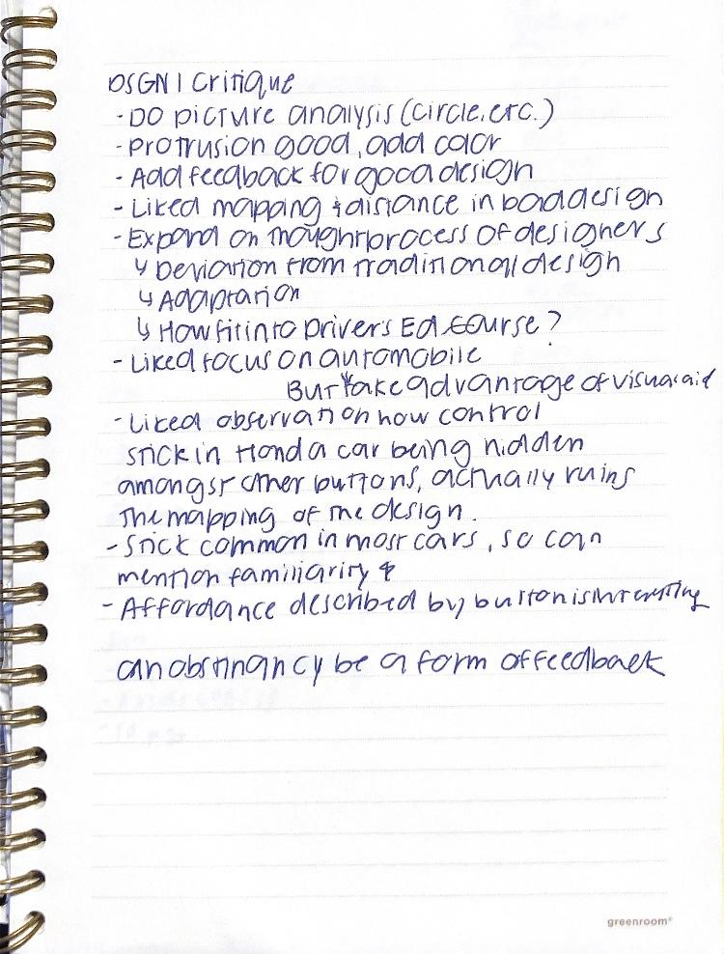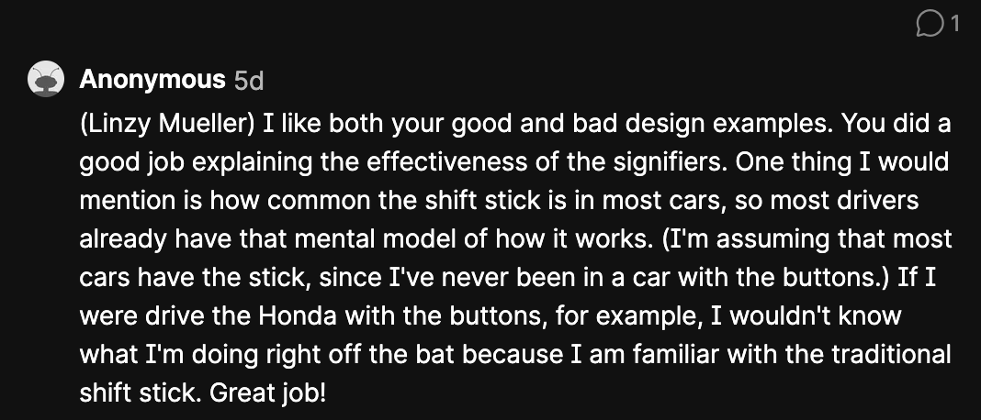

Figure 6: Padlet critique on good design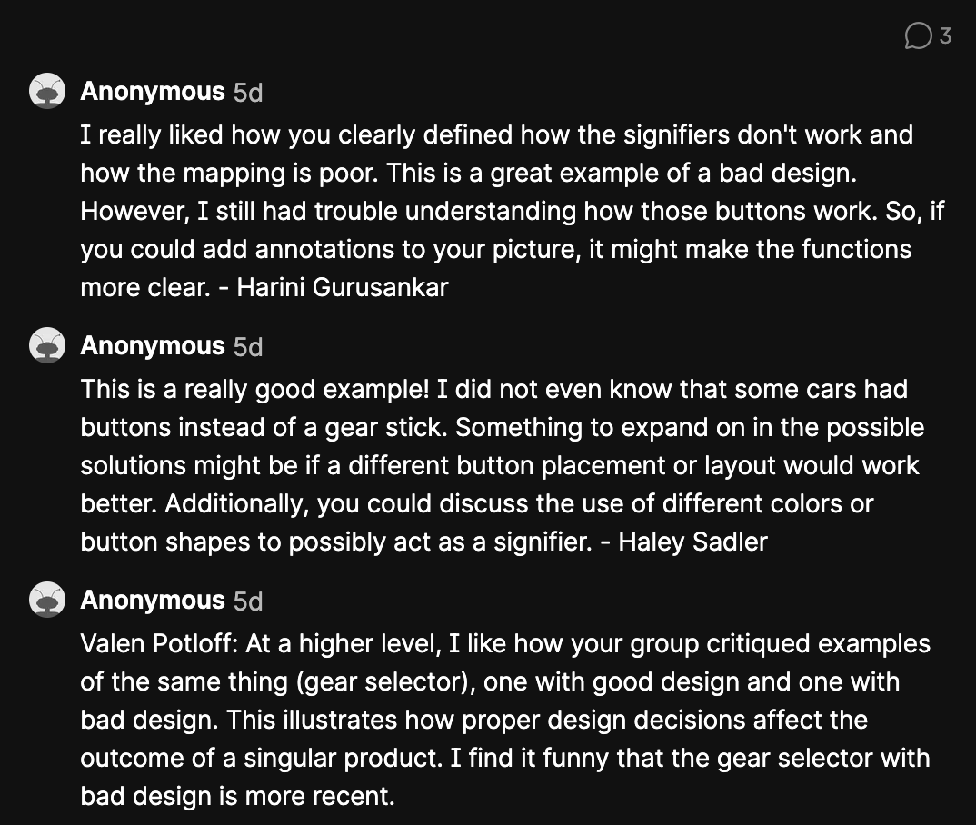

Figure 5: Notes from live critique Figure 7: Padlet critique on bad design

These critiques were really helpful in affirming which parts of the design observations others also were really perplexed by, as well as pointing out possible solutions to better our analysis! We were able to further our understanding of the design by considering external factors like the familiarity due to consistency across car models, as well as how maybe the button system isn’t a terrible idea, but rather the current placement (see Figure 7).

**Contributions**

We weren’t sure if we were supposed to include this part, as it’s written on the instructions but not the rubric, but we each contributed an equal amount of effort and time. We had really clear and supportive communication, and were extremely flexible in times to meet - had a great time working together!



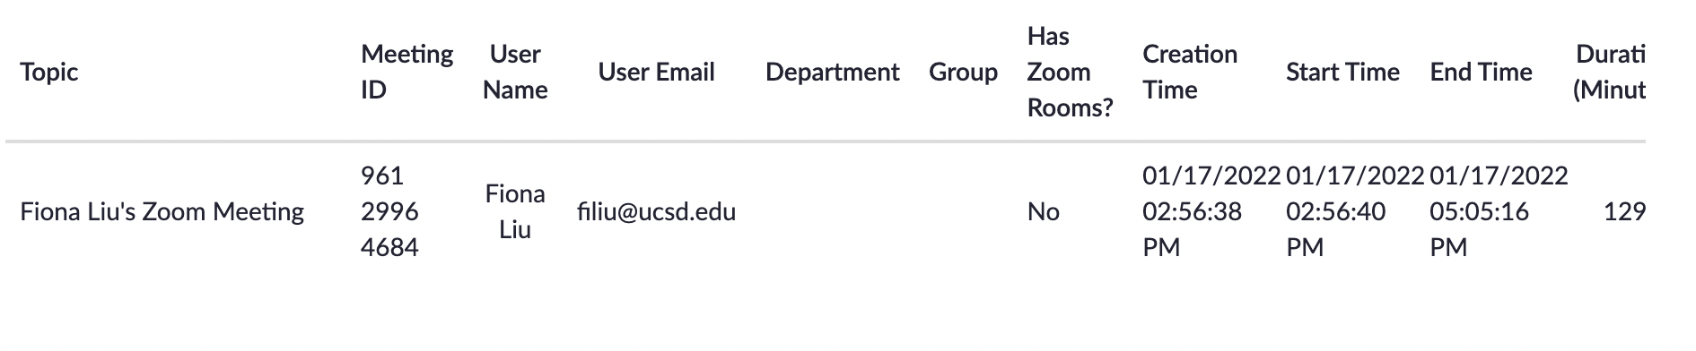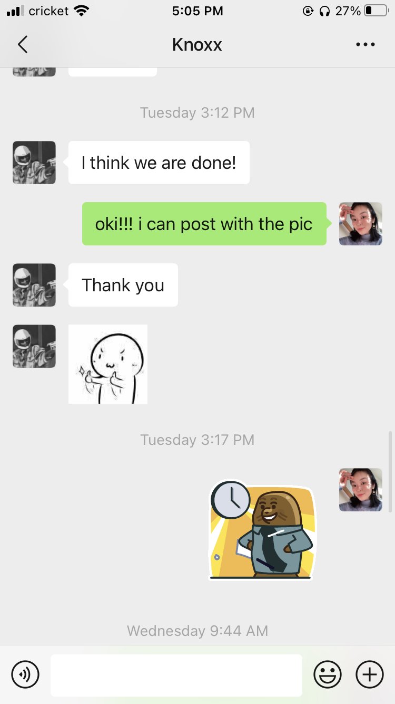

Figures 8 & 9: Supportive chats with cute emojis! Figures 10 & 11: Our Zoom log for this project!